Vikram Karandikar
Professor Greenberg
IDEA 106-1.03.1
2 November 2006
Portable and Potable Water: The Brita Chrome
A recent USGS study found that “the Midwest has a high risk of ground-water contamination by nitrate, but parts of the western and northeastern United States also are high-risk,” supporting the belief of nitrate contamination of groundwater across the United States (“Contamination of Ground Waters”). With growing concerns over the potability of regular tap water, many consumers have focused on bottled water and water filtration systems to quench their thirst. While these alternatives come without a dose of chlorine and weird tasting minerals, they are not the most convenient physically or financially; buying Aquafinas on a regular basis is too expensive and one is not guaranteed to find a faucet to attach a water filter to. Faced with this dilemma, Brita Chrome, a water purification pitcher, comes to the rescue. Not only does it incorporate activated carbon for a crisp and clean taste, but also its sleek design makes it convenient to place in an office, home, or dormitory setting. The Brita Chrome, however, has met tremendous success primarily because it relies on a conceptual design, has been thoroughly “idiot-proofed,” provides the user instant feedback during operation, and involves a setup that emphasizes simplicity and portability.
The Brita Chrome is conceptually designed
In The Design of Everyday Things, Professor Donald Norman states that “the operation of any device…is learned more readily…and easily, if the user has a good conceptual model” (189). One of the biggest concerns in modern design is that engineers deviate from a conceptual model, building products that do not allow users to instinctively know how to use them. This is not the case with the Brita Chrome. The overall look of the pitcher is identical to a normal household pitcher consumers have used since they were young and had lemonade stands. The handle is large and visible, and its contoured shape allows it to be gripped with ease. Because the Chrome “looks” like a pitcher, the spout also juts out and has a small angle so water may be poured with convenience.
The pitcher is also designed to mirror the mental image a consumer has of the filtration process. Conceptually thinking, a consumer would predict that impure water would be added, purified by a filter, and finally the pure water would be stored in a separate compartment. The Brita Chrome is set up exactly in this way. It consists of two compartments with the filter intervening in between. A lid on the top is tilted open to give access to the “impure compartment”(Figure 1). The opening to the impure compartment is large enough to hold under a faucet or pour water into from a cup. At the base of this compartment is the head of the cylindrical filter. Gravity forces water to go through the filter. The water trickles down the filter and into a separate, sealed chamber. The purified water will remain in this “pure compartment,” (Figure1) away from the impure water on the top. Thus by using a conceptual model, the Brita Chrome easily translates the user’s mental expectations of the product into a tangible, easy-to-use item.
The Brita Chrome is “idiot-proofed”
Conceptual modeling aside, another challenge engineers face is “idiot-proofing.” Specifically, this is designing a product in such a way that it may only be used or assembled in one—and the correct—way. Norman further emphasizes that designers need to “assume that any error that can be made will be made” (200). This is apparent in USB cables that only connect right side up as well as the Brita Chrome pitcher. The top of the pitcher is deliberately designed with one end being slightly larger than the other, creating a slight trapezoidal shape instead of a perfect rectangle. This modification is crucial because during assembly, the plastic lid will fit properly only one way.
A similar concept has been used for inserting the cylindrical filter. There is a small groove made into the plastic tubing(see Figure 1) the filter goes into so that during assembly the filter has to be oriented the right way in order to create a snug seal. Also, a special lip has been built over the spout so that users will not try to fill water directly into the “pure compartment.” Additionally, the Brita Chrome has a thumb-shaped plastic piece jutting out at the end of the “impure compartment” lid, indicating to users the opening to the chamber.
The Chrome pitcher itself comes with a small booklet of instructions. This is not surprising considering the “idiot-proofing” found inherent in the design of the product. All of these small features combine to make the product instantly accessible to the user, whether he or she is a techno-savvy teenager or a retired grandparent.
The Brita Chrome provides instant feedback
Regardless of the user, a well designed product never fails to provide feedback to the user. Norman describes feedback as “sending back to the user information about what action has actually been done, what result has been accomplished” (27). The Brita Chrome incorporates this concept in its design. For example, the user must not wait half an hour to check if the filtration process is occurring properly; the clear body of the Chrome allows the user to see the pure water drip down into the “pure compartment.” The clear body of the Chrome also enables users to easily check the water level in the “pure compartment,” without any manipulation of the Chrome or disassembly of the top cover.
The Brita Chrome has a simple and portable setup
Simplicity in access goes hand in hand with simplicity in design. Many engineers forget to visualize the operation of a product by their prospective user and do not “think of the user’s point of view” (Norman 140). Designers of the Brita Chrome certainly have paid attention to the needs of the user. The Brita Chrome does not ask much of its user; filling a pitcher with water is a relatively simple task. The simple design of the Brita Chrome allows for easy disassembly, enabling the user to clean the pitcher with ease or replace the filter when necessary. Atop the Chrome is an electronic filter change indicator, a green light which changes color when a new filter is necessary.
The self-contained design allows the Brita Chrome to fit in a regular-sized refrigerator door. Furthermore, the self-contained design allows and encourages portability because the pitcher itself does not occupy too much space like a 36-pack of bottled water nor does it need a constant source of tap water like the attachable filters. Thus, the sleek design and lack of any attachments make the Brita Chrome a perfect addition to an office, home, or dormitory environment.
It should be noted, however, that even with all these provisions, the Brita Chrome is not a perfect product. The filter inside the pitcher needs to be changed every two months. Carbon particles sometimes disintegrate and can be found in the “impure compartment.” Also, if the water level in the “pure compartment” goes below the mouth of the filter, the filter can dry out and reduce the effects of the filtration process. However, through smart and active consumer involvement these problems cease to exist. For example, during constant use of the Brita Chrome, it is unlikely that the “pure compartment” will be empty for large amounts of time. Also, the $31.99 price tag seems very reasonable considering the hundreds of dollars one would have to spend on bottled water and the inconvenience one would suffer through an attachable filter.
Conclusion
Through conceptual modeling, “idiot-proofing,” instant feedback, and a simple, portable setup, the Brita Chrome delivers a portable and easy to use mechanism for filtering tap water. In an age of growing needs and confusing technologies, the Brita Chrome brings simplicity to solve a problem many people face about the quality of drinking water. What makes the Brita Chrome unique in its approach is that it considers the needs of the user, the mental images the user has of the product, and the possible problems the user might have with the product instead of simply showing off filtration technology. By taming and conforming a water filtration system to what users have seen before, the Brita Chrome delivers a simple and successful product.
Figures
Figure 1
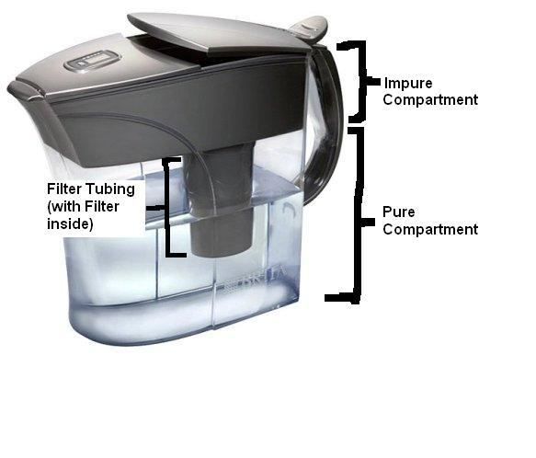
Works Cited
“Contamination of Ground Waters.” United States Geological Survey. 10 Jan 1998. 28 Oct 2006. < http://water.usgs.gov/nawqa/wcp/>.
Norman, Donald. The Design of Everyday Things. New York: Basic Books, 2002.

