An Analysis of Ice Cream Cone Design
Ice cream and its ubiquitous container, the cone, are among the most popular treats in America. Over 90% of US households consume ice cream or other frozen deserts each year (IDFA). Everyone who has ordered an ice cream cone knows the inevitable next question: “Sugar cone or cake cone?” The answer is a decision between two items that fill essentially the same role. In the open and highly competitive marketplace of cones, at first it seems surprising that neither design has dominated after many decades of ice cream containment. Sugar cones and cake cones each have distinct characteristics that appeal to different people.
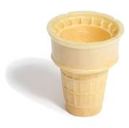
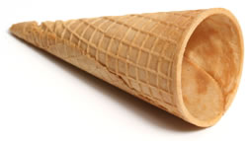
There are two main types of ice cream cones: cake, also known as wafer, and sugar. Sugar cones and cake cones each function as portable, eatable ice cream holders. The sugar cone is made by pouring batter into waffle-iron-like molds. Once baked the waffles are rolled into cones and harden as they cool (Figure 1). Sugar cones are typically finished at the top before cooling to provide a smooth top.
Figure 2: The cake cone (Hormel)
2 inch (typical)
Figure 1: The sugar cone (Hormel)
4.5 inch (typical)
Cake cones, invented well after sugar cones are molded and typically flat bottomed (Figure 2) (IDFA). They contain far less sugar and are stronger than sugar cones due to their grid-like construction. They feature a flat bottom so the cone can be set down while eating. A trough just inside the outer rim of the cone is meant to catch drips. The two layered, grid construction of the interior of the cone also helps hold the ice cream in the cone. This makes it possible to dip the cones in chocolate or butterscotch, a treat impossible with sugar cones. Some people also prefer the mild taste of these cones.
Children are often given cake cones because they are less likely to break, are considered easier to handle, and can be set on a table when not being eaten. As seen in Table 1, the size of the grip is much smaller on a cake cone (2 inches versus 4.5 inches on a sugar cone). This makes cake cones more manageable for children with small hands, while the sugar cone is better suited to users with large hands.
Dimension (inches) | Sugar cone | Cake cone
Overall height | 4.5 | 3
Gripping height | 4.5 | 2
Inside diameter (ice cream opening) | 1.625 | 1.5
Table 1 Cone sizes (Data collected by author, based on EAT-IT-ALL cones from Hinman Dining Hall at Northwestern University)
Though the cake cone has many design advantages, most people prefer the sugar cone, and sugar cones command a premium price at most ice cream shops. In a survey by the author, 21 of 24 people questioned said they preferred the taste of the sugar cone (appendix contains full study). Many users see this cone as more ergonomic and aesthetically pleasing. The simple cone shape fits well in the hand and highlights the ice cream on top. Another characteristic of the sugar cone is its tendency to drip at the bottom. Many people find this to be a problem however some reported that they enjoy sucking the melting ice cream from the bottom. Many people can recall this activity from their youth.
Perhaps the two most important design factors that lead people to choose the sugar cone are the texture and flavor. The sugar cone is sweeter and more flavorful than the cake cone. Sugar cones contain about 25% sugar while cake cones are only about 5% sugar (IDFA). In the baking process some of this sugar is caramelized giving sugar cones a darker color, more flavor, and a crisper texture that many people enjoy.
This improved flavor comes at a cost. The cake cone is more structurally sound than the sugar cone. A test performed by the author on cone strength showed sugar cones to be 63 percent weaker than cake cones (appendix contains full study). For this reason accidentally breaking sugar cones is common and rarely seen with cake cones. Sugar cones are weaker, harder to eat, and tend to drip. These traits make them suited for experienced, skilled ice cream eaters. Cake cones are stronger, stand on their own, and have the drip trough, making them good for younger or less able eaters.
Many measurable design characteristics differentiate the two distinct cone designs, and both designs solve the same problem in quite different ways. The final decision, however, comes down to personal preference on flavor, texture, ergonomics, and eating experience. Because of a broad spectrum of advantages and disadvantages, neither cone is clearly better suited to the task of holding ice cream. As long as consumers remain diverse in their cone tastes both designs will continue to faithfully contain ice cream.
Appendix
Survey on cone taste preference
Performed on November 2, 2006 by the author
Do you prefer the taste of sugar cones (pointy bottom) or cake cones (flat bottom)?
Sugar | Cake
21 | 3

Cone strength test
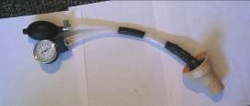

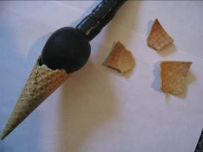
I tested the strength of cones against a force exerted from the inside out. The test apparatus consisted of the pump and gauge from a blood pressure cuff attached to a balloon (Figure 3).
Figure 3: The cone testing apparatus
When inflated the balloon exerted a force on against the inside of the cone. I was able to record the air pressure in the balloon using the pressure gauge from the blood pressure cuff. I recorded the pressure at which I could hear or see cracks forming in the cone and the peak pressure when the cone broke.
I averaged the breaking point pressures for each type of cone. I also performed a Student’s t-test to test the null hypothesis that the difference between the groups was a result of chance.
The average breaking point was 106 mmHg for the cake cones and 67 mmHg for the sugar cones. The P value obtained from the t-test was 0.004, well below the typical threshold for statistical significance, 0.01. Thus the null hypothesis is rejected and the cones do differ significantly in strength with the cake cones well in the lead.
The way the two types of cones broke during the test is equally interesting. Sugar cones broke quietly and usually into four or fewer pieces. There was no preliminary cracking. The cake cones broke much more violently. They started cracking about 20 mmHg before they finally exploded with a great pop into a pile of little pieces (see Test Pictures).
This test nicely demonstrated the result of the differences in the structure of each type of cone.
Test Pictures
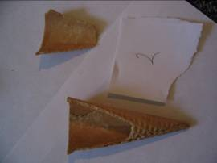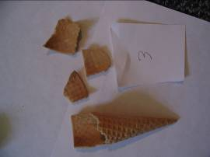

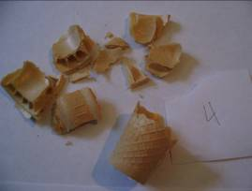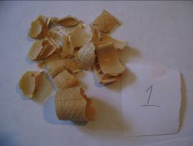

Test Data
Cone | Type | Crack Pressure (mmHg) | Break Pressure (mmHg)
1 | Cake | 100 | 120
4 | Cake | 80 | 100
7 | Cake | 80 | 100
8 | Cake | 90 | 105
2 | Sugar | - | 60
3 | Sugar | - | 80
5 | Sugar | - | 90
6 | Sugar | - | 70
9 | Sugar | - | 70
10 | Sugar | - | 70
11 | Sugar | - | 30

 | Cake | Sugar
Mean | 106.25 | 67.14285714
P(T<=t) two-tail | 0.004143
Sources
International Dairy Foods Association (IDFA). “July Is National Ice Cream Month.” http://www.idfa.org/facts/icmonth/page1.cfm
IDFA is an organization representing dairy manufacturers in the US. Their site provides information about many dairy products.
Hormel Foods. “Ice Cream Cones.” <http://www.hormel.com/kitchen/glossary.asp?id=36327&catitemid=>
Hormel Foods is a manufacturer of ice cream cones and other food products.

