David Henning Fall Quarter Final
106-1.3.1.06-11-02
Professor Michelle Greenberg

Ice Mountain Sports Bottle
The mantra of form following function is the hallmark of the engineering discipline. While it may seem that stripping features until an object is bare would yield the swiftest route to completing a simple function, real solutions of true problems are often more elegant than ungainly or rudimentary. When the notion of function is taken in all of its parts, it includes, along with the most basic of motions, interaction with the user and the environment. A designer is faced with the challenge of molding technology to meet the movements of the human body and not requiring the body to adapt to ill-created technology. The most successful designs don’t draw attention to themselves, but rather remove from a process done thousands of times the inconveniences the habitual user didn’t even know existed. The Ice Mountain sports bottle effectively exemplifies this ideal of user-centric design in a seemingly mundane object.
The job of a water bottle in its simplest form may lead to the false assumption that it is easy to design and engineer. True, if it holds liquid and provides an opening for consumption, a capable user can make it work, but there shouldn’t be a struggle. Ice Mountain displays a variety of containers on its website, each with dozens of testimonials as to its usefulness, but all that is needed to understand the near perfect design of the sports bottle is to analyze it within the context of the company’s own advertising slogan: grip it, flip it, sip it.

Grip it
The Ice Mountain sports bottle utilizes the popular design approach of being accessible and convenient for as many people as possible. One might imagine a cylindrical bottle with entirely smooth edges as equally accessible to nearly all pairs of hands. It would also be equally inconvenient. A bottle with no grip requires thought to execute even the simple process of drinking. How high up on the cylinder should a bottle be gripped to avoid slipping? Is it narrow enough to be grasped in one hand? Would a second hand better stabilize it? Ice Mountain employs a symmetrical design to keep the product as equally accessible as possible while delivering universal convenience and comfort.
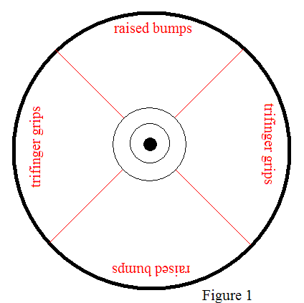
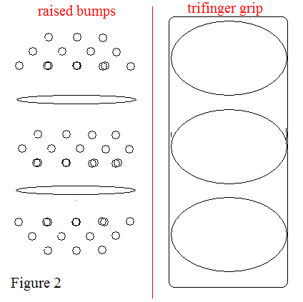
If the plastic of the bottle were to be divided into quadrants (Fig.1, bottle as seen from the top), the plastic of two opposing ones protrude in an array of raised bumps (Fig. 2, detail of gripping mechanisms). The concept is an adaptation Mother Nature uses often. Just as the ridges on the foot of a gecko or the hairs on the leg of a housefly allow each respective creature to grip to walls, the extra surface area of the protrusions creates enough friction to help the thirsty user keep the bottle in hand.
The two quadrants contain indentations to guide the user’s fingers into an appropriate site for gripping. Even without looking at the bottle, the raised slopes between the depressions naturally slide to meet the cracks between individual fingers. The three indentations form a trifinger grip (Fig. 2) that, at first glance, appears unrefined. Certainly this seems a miniature version of the same concept as a cylindrical bottle. The simple shape of an ellipse no more matches a finger than a cylinder matches the whole hand. Here, while it would be no significant increase of effort in manufacturing to match a hand or finger exactly, the Ice Mountain sport bottle’s designers appropriately drew the line for universal usage. The grip allows for fingers of varying size and position, regardless of the bottle’s orientation. Perhaps most ingeniously of all, the finger depressions are large enough for the thumb to fit into one on the opposing side. While a more exact fit was sacrificed, the value of its universal fit is incalculable. Either hand placed on either side of the bottle yields the same effective grip.
And what if the user inadvertently rests the palm of the hand over the trifinger grip? The other quadrants contain two raised bars that generate a rougher approximation of the grip and allow for easy, if not optimal, use (Fig 2.).
Flip it
The second part of Ice Mountain’s slogan deals with the motion specific to sports bottles in which the user turns the bottle upside down to either take a sip or squeeze a jet of liquid into the mouth. A conventional bottle allows for only the tilting of the opening as one would drink from a cup, and so this additional motion adds a degree of complexity to design.
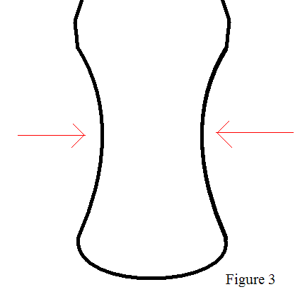
To facilitate the action of flipping, the bottle is concave in its midsection (Fig. 3). Much in the same way that an arrow or grappling hook is too wide to retract through the orifice through which it has been shot, the wider portions of the bottle on either end of the concave grip prevent the bottle from slipping out of the hand whether in the traditional or inverted orientation.
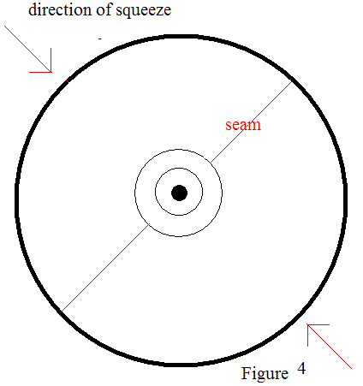
As to the squirting implication of the flipping motion, the plastic of the Ice Mountain sport bottle is far more malleable than competing containers. This, when combined with two seams in the plastic that provide creases of least resistance ( Fig. 4), allows for the easy squirting of the bottle without permanently causing denting or distortion. By comparison, Aquafina and Dasani bottles produced by soft drink giants Pepsi and Coca Cola collapse when squeezed and could potentially never recover their original shape.
Sip it
The final action described by the slogan is the physical consumption of natural spring water. While the tapered opening looks similar to the caps of competing sports bottles, there is one novel development of note.
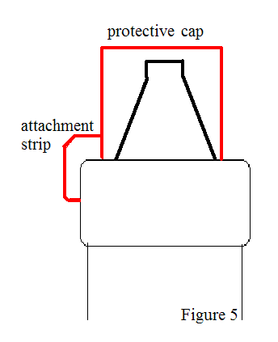
On a standard sports bottle, the protective plastic cap is a separate piece from the rest of the bottle. This protective over-cap fits atop the drinking opening and affectively keeps dirt from the mouthpiece. It is easily lost. To solve this problem, Ice Mountain attaches its cap with a thin strip of plastic so that it remains attached to the main part of the bottle (Fig. 5). The mouthpiece will be clean long after the user would have lost the separate protective covering.
The Ice Mountain sports bottle is a designing and engineering marvel. It effectively achieves a distinctive and sensible solution for the minute details of drinking from a container, and it clearly is the product of a thorough design process; each feature contributing to a step in its self-styled instructional slogan: Grip it, flip it, sip it. Were the bottle any better designed, it would scarcely be noticed by even the discerning eyes of engineers.

