HandsOff!
Adaptive Solutions for Adaptive Skiing

Client
Barbra M. Aronowski
Rehabilitation Institute of Chicago

Northwestern University, Engineering Design and Communication
Section 21 Team 4

Laura Figel
Christine Lee
Sunny Lin
Erin Tekin

Professors Buckley Crist and Penny Hirsch

March 11, 2006

Table Of Contents

Executive Summary……………………………………………………………………….1
Introduction………………………………………………………………………………..2
Design Concept……………………………………………………………………………3
Description of Design……………………………………………………………..3
Support…………………………………………………………………………….4
Background Research……………………………………………………………………..5
Methods…………………………………………………………………………....5
Findings…………………………………………………………………………...5
Implications For Alternatives……………………………………………………..7
Alternatives………………………………………………………………………………..8
Concepts…………………………………………………………………………...8
User Testing…………………...…………………………………………………..9
Alternatives Evaluation…………………………………………………………..10
Next Steps………………………………………………………………………………..12
Ease of Installation……………………………………………………………….12
Reliability of Trigger…………………………………………………………….12
Additional Options……………………………………………………………….13
References………………………………………………………………………………..14
Appendices……………………………………………………………………………….15
Appendix A: Project Definition………………………………………………….15
Appendix B: Research Questions………………………………………………..17
Appendix C: User Observation Summary……………………………………….18
Appendix D: Hypothetical User Profile………………………………………….19
Appendix E: User Testing Summary…….………………………………………20
Appendix F: Clustered Brainstorming List………………………………………22
Appendix G: Final Design Concept Sketches……………………………………24

List of Figures
Figure 1- HandsOff! Attachment…………………………….……………………...…….1
Figure 2- HandsOff! Installed On Outrigger……..……………………………………….1
Figure 3- Existing Trigger……………………………………...…………………...…….2
Figure 4- HandsOff! Disengaged………………....………….……………………………3
Figure 5- HandsOff! Engaged……………….…………………..………………………...3
Figure 6- Pole Clamp……………………………………………………………………...3
Figure 7- Monoskier………………………………………………………………………5
Figure 8- Bi-skier………………………………………………………………………….6
Figure 9- 3-Tracker………………………………………………………………………..6
Figure 10- Tetraglove………………………..……………………………………………7
Figure 11- Button Mockup……………….……………….……………………………….8
Figure 12- Low-String Release Mockup………..…………………………………………9
Figure 13- Moving Foot Mockup…………………………………………………………9
Figure 14- Prototype Version 1…………………………………………………………12

List of Tables
Table 1: Summary of User Comments and Suggestions………………………………...10
Table 2: Decision Matrix ……...………………………………………………………...11
EXECUTIVE SUMMARY

The goal of the outrigger design project was to modify the Superlite™ ski outrigger that would allow adaptive skiers who rely on the Superlite™ outrigger to ski without outside assistance. Some users are unable to use the outriggers independently because they lack the range of motion and strength necessary in their fingers to trigger the outrigger’s conversion from ski to crutch and back. These users include, but are not limited to, tetraglove users whose hands are bound to the outrigger and children whose hands are too small to reach the trigger.

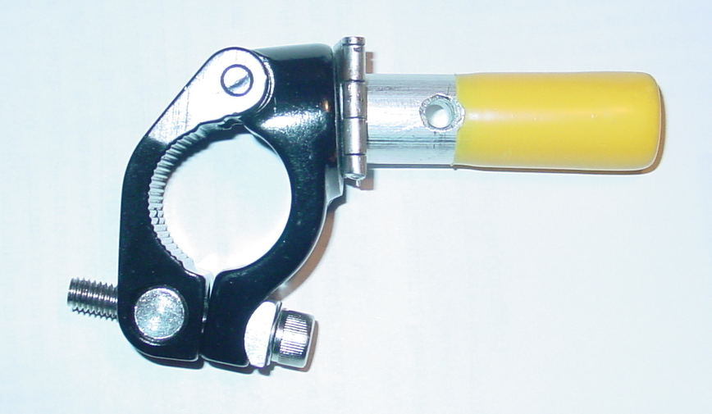
Our team worked on a mechanism that could be easily attached to the current ski outrigger and that could be used by all users regardless of their hand capabilities. We came up with “HandsOff!,” a hinged aluminum lever attached to a clamp (see Figure 1: HandsOff! Attachment.) The clamp in our prototype is very simple to install, requiring only an Allen wrench to tighten it onto the outrigger pole. This clamp can be attached anywhere on the main pole making it adjustable to people of all heights.
Figure 1: HandsOff! Attachment

When the lever is pulled up, the existing outrigger cord is also pulled, releasing the ski tip so that it is free to shift into crutch or ski mode. When no force is applied, the lever is released back into its resting position due to the tension of the outrigger cord. The tension in the cord is created by a spring that wraps around a peg at the end of the outrigger cord. The peg locks the ski tip into its crutch or ski position. When the cord is pulled, the spring compresses and creates tension—the spring wants to go back to its relaxed state, pulling the lever back down.
Figure 2: HandsOff! Installed On Outrigger
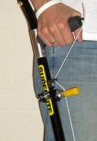
HandsOff! has several foreseeable benefits. One benefit is the significant decrease in force required to change the ski tip from one mode to another. The original outrigger requires a force of 4.5 N to trigger, the outrigger with the HandsOff! adapter requires only 2.2 N to trigger—more than a 50% difference. Another benefit of HandsOff! is its ability to adjust in order to accommodate a wide range of motions. Because of the clamp’s unique properties, the device can be adjusted height-wise and around the pole axis. The third main benefit of HandsOff! is the fact that the original cord trigger of the outrigger is still maintained. The cord pulls through the HandsOff! device and can be reattached to the outrigger so that the original triggering method is still available to use (See Figure 2: HandsOff Installed On Outrigger).

We designed the HandsOff! device so that all skiers, regardless of hand capabilities, could push the device against themselves or the sit-ski chair and trigger the lever.
INTRODUCTION

Recreational skiers at the Rehabilitation Institute of Chicago want an adaptation to their ski outrigger that will allow them to change from crutch mode to ski mode and back regardless of their hand capability. These skiers are people with hemiparesis, hemipeligia, or quadriplegia, or are survivors of strokes or accidents that cause brain damage. In many cases, they cannot use their arms or hands, or have limited strength in them.

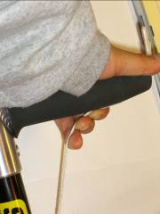
The current outrigger requires each user to use their four main digits to pull up on the cord and release the ski tip (see Figure 3: Existing Trigger). The pulling of the cord triggers the mode switch between crutch and ski. However, some skiers do not have the hand strength or size to reach the cord and trigger the mechanism. Several of our users also require the use of a Tetra Glove, which binds their hand to the handle of the outrigger, requiring an assistant to pull the string and release the ski tip. Our client and a user that we interviewed noted that they would prefer an outrigger that the user can use independently. The client specifically wanted a modification or an add-on to the existing outrigger so that skiers will be able to use it soon as possible. (See Appendix A for the project definition and specifications.)
Figure 3: Existing Trigger

This report proposes an attachment to the existing outrigger to solve this problem: Hands Off!. We first describe Hands Off!, explaining its features and benefits. Then we review the processes we used to arrive to the final prototype, including our preliminary project research, concept generation, and concept evaluation.
DESIGN CONCEPT

Description of Design:

The HandsOff! attachment functions as an add-on modification to the Superlite™ ski outrigger currently being used by adaptive skiers at the Rehabilitation Institute of Chicago. It is designed as a tool for users with weak hands to enable them to trigger the change from ski crutch to ski blade and back with little effort.

HandsOff! attaches to the outrigger by a commercially available pole clamp that tightens around the outrigger’s 1” diameter main pole (see Figure 4: HandsOff! Disengaged). The outrigger’s original cord, which is normally pulled by the user’s fingers, is disconnected from its current position on the outrigger and threaded through the movable peg. A knot is tied on top of the HandsOff! position that catches on the peg when lever is pushed up. The cord is then reattached to the original position on the handle. With this arrangement, the user can trigger the outrigger’s conversion by simply lifting the peg (see Figure 5: HandsOff! Engaged) or using the existing trigger.

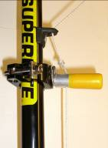
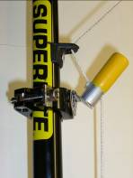

Figure 4: HandsOff! Disengaged
Figure 5: HandsOff! Engaged
Feature 1: The Pole Clamp

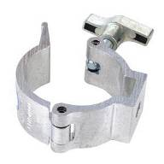
The pole clamp provides an easy and secure way to attach the Hinge Clamp to the outrigger. It can be adjusted by hand or by a tool, such as an Allen wrench, depending on the type of clamp used. The clamp in Figure 6 is adjustable by hand; the clamp in our prototype, which is intended for a bicycle seat, is adjustable by an Allen wrench in order to secure a tighter fit.

The pole clamp is easily adjustable to ensure the easiest use for each user’s specific needs. It can be adjusted both vertically and around the pole axis to accommodate a wide range of motions.
Figure 6: Pole Clamp (http://www.abbeylighting.co.uk/)

Feature 2: The Hinge and Peg
The hinge allows for one-directional movement of the attached peg. When an upward force is applied to the peg, the hinge allows the peg to move up, pulling the outrigger string and triggering the outrigger conversion (see Figure 5). This specific and intentional motion limits the chances of accidentally triggering the device. The 2” peg is also coated in PlastiDip, a rubber coating found in hardware stores that gives the peg a more comfortable and firmer feel. It provides a grippable surface for the user to use when triggering the lever.

Support:

User testing revealed that users have very different ranges of motions depending on their different disabilities. We decided that the outrigger adaptation should be both adjustable and functional in many different positions. Thus, Hands Off! is capable of being placed in different places on the outrigger ski pole and requires only the slightest, but still intentional movement to use. The device is also ideal because it is independent of hand capabilities, and the motion required to trigger it cuts the current required force in half. At the same time, any user who prefers the existing mechanism will still be able to use it.
BACKGROUND RESEARCH

Methods

We gathered information about the design problem from conversations with the client, the Internet, and observations at the user meeting. Each method is briefly described below:

Client Meeting

The client meeting on January 17th, 2006 with Barbra M. Aronowski, a program specialist from the Rehabilitation Institute of Chicago, gave us an idea of the client’s goals for the design project and the flaws of the current outrigger design.

Web Research

Our team researched user disabilities and capabilities on the Internet. Several sources that were useful for this project were the Children’s Hemiplegia and Stroke Association, Sitski, Pubmed, and Adaptive Adventures. Full bibliographic information is available on the Reference Page.

User Observation

On January 24, 2006, we traveled to the RIC to observe and interview a survivor of stroke who will be using the design next month. We were able to watch the user interact with the existing outrigger model and to learn about her requests and her physical limitations.

Findings

I. Uses
- There are three ways that the outrigger is used:

1. Mono Skiers sit in molded seat mounted to a frame above a single ski. Monoskiers generally have good upper body strength, trunk mobility, and balance. (see Figure 7: Monoskier)

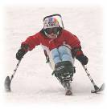
Figure 7: Monoskier
(www.skiwas.org/prog.html)
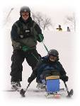
2. Bi-skiers sit in a shell with two modified ski blades attached to it. Bi-skis are usually used by skiers who have more extreme injuries or conditions such as spinal cord injury, brain injury, muscular dystrophy, and spina bifida. Bi-skis are wider and provide more balance than the mono ski. Bi-skiers have the option of using fixed outriggers and a handle bar as well as the normal two outrigger option. (see Figure 8: Bi-skier)
Figure 8: Bi-skier
(www.skiwas.org/prog.html)

3. 3-Trackers are skiers with partial or no use of one leg. 3 Trackers have one sound leg and two sound arms. (see Figure 9: 3-Tracker)

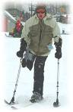
Figure 9: 3-Tracker
(www.skiwas.org/prog.html)

- Outriggers have 2 functions:
1. As a ski tip, the outrigger has a ski blade for smooth movement across snow while skiing
2. As a crutch, the outrigger has a treaded foot for traction

II. User base: Our users are skiers who have difficulty with the current design of the outrigger. They can be classified into three main groups:
1. Amputees, with no use of their hand or hands, cannot pull the mechanism to change outrigger modes
2. Users with weak hands lack the hand strength to trigger the mechanism
- Quadriplegics have good arms and triceps but lack finger strength and control; thumbs are generally strong
- Hemiplegics have total paralysis of one side of the body, they have no thumb or finger strength on that side
- Hemiparesis patients have partial or weak paralysis of one side of the body; thumb and finger strength is weak
3. Users with small hands, such as children, lack the hand span to reach the cord and often lack the hand strength to pull up on it as well

A brief note: The Tetraglove is a glove designed for users who lack the hand strength to hold on to the outrigger. The glove straps the users hand to an object. However, it inhibits the fingers so that the thumb is the only digit that is free. (See Figure 10: Tetraglove)

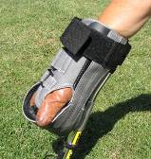

Figure 10: Tetraglove
(http://www.spokesnmotion.com/products_shop/product_detail.asp?product_id=1028)

III. Current Models
- Ski outriggers are made by two main companies
- Radventures-yetti has an adult model and a children’s model.
- Enabling Technologies (a.k.a. Superlite) has three models: a standard model, a competition model, and a tall model.

Implications for Alternatives

Our research findings had implications for aspects of our alternative concepts:

Trigger Mechanism

User observation and further research revealed that users have a wide range of capabilities. The user we interviewed had no reliable use of her fingers or thumb. Therefore, mechanisms involving use of the thumb or the fingers cannot be adaptable to all users. Other mechanisms that might be more feasible are: air pressure, electronic devices and sensors, pressure sensors, pull cords or electro-magnets; and/or the trigger could be activated by another body part, such as the foot or the leg.

(For more information, see Appendix B: Research Questions and Appendix C: User Observation Summary)
ALTERNATIVES

Concepts

In preparation for our first user meeting, our team made 3 of our preliminary design ideas into mockup alternatives. Each mockup was designed to answer several questions to help us advance in our design process. Our alternatives: the button, the low release, and the moving foot, present the user with three different methods of releasing the ski tip from crutch to ski and back. We needed to see which mechanisms the user could trigger by having them test a mock-up of each alternative.

This section describes each mockup in detail and discusses the general questions that each alternative was intended to answer.

Mockups

- Alternative 1, the button concept, uses a button to trigger the outrigger (see Figure 11). A button is placed within the handle and when it is pushed, it will displace the outrigger cord, which will enable the outrigger to be converted from ski to crutch.
Figure 11: Button Mockup

Mockup 1 was intended to answer the following questions:

Can the user reach the button?
Can the user engage the mechanism with limited hand strength?

- Alternative 2, the low release concept, moves the existing mechanism to the bottom of the outrigger pole (see Figure 12: Low-Release Mockup). The cord is displaced in the same way the original outrigger’s cord is except using a rod that is attached to the opposite pole instead of the user’s fingers.

Mockup 2 was intended to answer the following questions:

Will the user have the coordination and strength to operate the device?
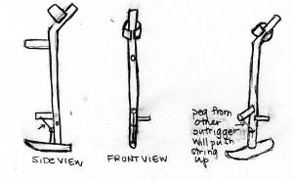
Will the manner in which the device must be activated be safe for the user?
Figure 12: Low-Release Mockup

- Alterative 3, the moving foot concept, is similar to the low-string release except that the rod, to which the string is attached, is now hinged making it into a lever, and the mechanism is triggered when the lever is pushed up. The lever is triggered by the same rod on the opposite pole as in Alternative 2, or by pushing it against something, such as a sit-skier’s chair, or a body part. (see Figure 13: Moving Foot Mockup)
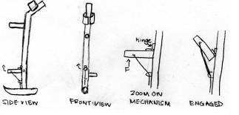
Figure 13: Moving Foot Mockup

Alternative 3 is intended to answer the following questions:

Will the release be reliable enough to trigger the release only when actively
engaged?
Will the user have the coordination and strength to operate the device?

User Testing

User testing occurred at the Rehabilitation Institute of Chicago on Feb. 16, 2006. This testing would become our primary source for deciding which design concept we would pursue. At this user testing, we simply explained to the user how each alternative releases the ski tip and had him try to engage each mechanism. The user’s comments and suggestions can be found in Table 1.

Table 1: Summary of User Comments and Suggestions

Model | Comments | Suggestions
Button | Button model is the most effective of the three  Button can be hit against something else if it cannot be triggered by the thumb | Make the button itself big so it is not difficult to push with a large surface
Low Release | Low-string is the least effective  Both ski poles need to be lifted to engage, leaving users without supports if standing  The poles get disorderly when engaging the mechanism  The mechanism is too low for sit-skiers | Find a placement of the release rod that doesn’t require that pole to be lifted  Make the release rod longer to avoid pole overlapping  Raise the mechanism to a more conducive height
Moving Foot | Low-hinge is the second most effective, almost equal to the button  The large lever-like property is helpful if something else (i.e. a body part or part of a sit-ski) will engage it  The mechanism is too low to release comfortably | Raise the mechanism to a more conducive height

Alternatives Evaluation

Based on the user testing results, we decided to focus on the moving foot design. Our decision was based on the user’s comments and the decision matrix found in Table 2 on the following page.

Table 2: Decision Matrix

 | Button | Low Release | Moving Foot
Ease in Triggering | + | - | ++
Comfort | + | + | -
Safety | ++ | - | ++
Accessibility | + | - | +
Practicality | ++ | - | ++
Overall | + | - | +
TOTAL | 8 | -4 | 7

KEY
- = does not satisfy the criterion
+ = satisfies criterion
++ = satisfies criterion extremely well

Although the moving foot design scored less than the button design, we felt that the moving foot design with the suggested alterations would surpass the button design. We felt that the areas in which the moving foot design scored poorly were easy to fix and the areas in which it excelled were more important.

(For more information, see Appendix D: User Testing Summary and Appendix E: Clustered Brainstorming List)
NEXT STEPS
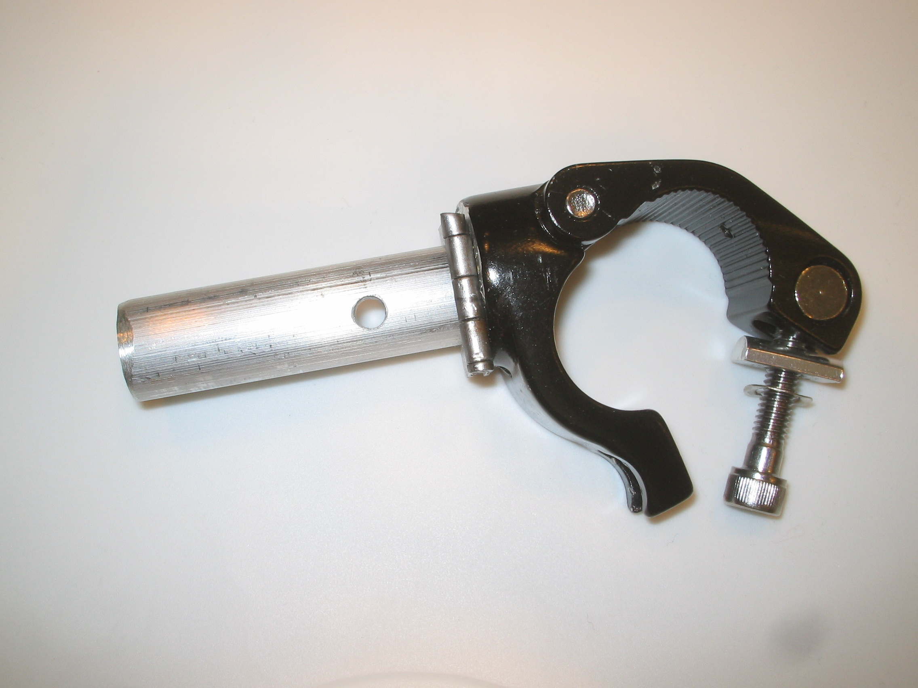
On Friday, March 3, 2006, we presented the first version of our hinge-attachment design (see Figure 14: Prototype Version 1) to Joel Berman, a program facilitator of the Adaptive Adventures program for adaptive skiiers. Mr. Berman, although not an adaptive skier himself, was able to effectively and easily engage the mechanism and assured us that the design would work regardless of a user’s hand capabilities.
Figure 14: Prototype Version 1

He commented on the design’s ability to adjust its placement on the ski pole depending on the user’s range of motion and made several suggestions, some of which we saw to reality, and others of which we will outline here along with suggestions of our own.

One of Mr. Berman’s suggestions was to place a rubber tip on the prototype in order to facilitate the lever’s grip and comfort. This addition can be seen in our final prototype (see Figure 1: HandsOff! Attachment).

Although the final design is complete and ready to use, for further improvement we recommend work in these areas:
Figure 1: HandsOff! Attachment

Ease of Installation

The clamp that is currently being used will require someone with significant hand capabilities to attach the device to the existing ski pole.

Questions to investigate include:

How might the tightening device of the clamp be altered so that someone with limited hand capabilities will be able to place it on their poles effectively?

Reliability of Trigger

One concern with the HandsOff! design is that the mechanism might be too easy to trigger and may be accidentally engaged.

Questions to investigate include:
How much tension can be applied to the cord without posing too much difficulty for the user?
Can the tension in the cord be changed without changing the entire outrigger?
What is the optimal placement so that the device can be triggered, but only when actively engaged?

Additional Options

Another feature that we foresee added to the HandsOff! adapter is another hinge option. Currently, the hinge only allows vertical movement of the lever. If, however, a user finds that the motion necessary to activate the lever vertically is too difficult, an open alternative to the vertical lever is a horizontal one. Simply rotate the hinge and peg 90 degrees in the desired direction and screw it back into the clamp.
REFERENCES

Abbey Lighting. 6 Mar. 2006 <http://www.abbeylighting.co.uk/>.

Children's Hemiplegia and Stroke Association. 9 Mar. 2006 <"Rocky Mountain Adaptive Certification Standards." 9 Mar. 2006 .>.

"Enabling Technologies Outriggers From Spokes 'n Motion." Spokes 'n Motion. 04 Mar. 2006 <http://www.spokesnmotion.com/products_shop/product_detail.asp?product_id=1028>.

"Hemiparesis - Wikipedia, the free encyclopedia." Wikipedia, The Free Encyclopedia. 9 Mar. 2006 <http://en.wikipedia.org/wiki/Hemiparesis>.
MedFriendly.com. 9 Mar. 2006 <http://www.medfriendly.com/quadriplegia.html:>.

Pubmed. 9 Mar. 2006 <http://www.ncbi.nlm.nih.gov/entrez/query.fcgi?cmd=Retrieve&d=pubmed&dopt=Abstract&list_uids=12578223&query_hl=2&itool=pubmed_docsum>.

"Recovering After A Stroke." The Internet Stroke Center. 9 Mar. 2006 <http://www.strokecenter.org/pat/ras02.htm>.

"Rocky Mountain Adaptive Certification Standards." 9 Mar. 2006 <http://www.psia-rm.org/pdf/Adaptive/ASBentrylevexammatrl.pdf>.

"What Is Adaptive Skiing And Sports?" 9 Mar. 2006 <http://www.sitski.com/whatisit.htm>.

Wintergreen Adaptive Skiing Program. 9 Mar. 2006 <www.skiwas.org/prog.html>.

APPENDICES

Appendix A: Project Definition

Mission Statement

To create or modify an adaptive ski pole/crutch that can be utilized by and support people with disabilities regardless of hand capabilities.

Users and Stakeholders

- Primary users with limited capacity involving their hands
  - Amputees (no hands)
  - Children (weak hands with small span)
  - Weak hands (stroke survivors, M.S., etc…/tetraglove users)
- Client (RIC)
- Trainers/People who are involve with the users’ daily lives
  - Family members
  - Ski instructors
  - Employees of resorts
- Manufacturer

Constraints

Device must be an adaptation or modification of the original outrigger.

Requirements | Specifications
Function  - Must convert from crutch to ski tip  - Must be easy to release ski tip with the trigger  - Must support user weight  - Must be usable with ski lift (get on and off)  User Convenience  - Ability for user to utilize without assistance  - Easy to transport  - Limited weight  - Must be adjustable for different user heights  - Must be usable with different hand spans  - Must be usable with a tetraglove | - Must not require more than 4.5 N to engage  - Must be able to support at least 250 lbs  - Device to trigger must not lock limbs in any one position  - Straps must be able to put on without relying on hand strength  - Device must be internal or close to the pole itself, or collapsible
Safety  - Must not cut users  - Must be reliable/durable  - Must not chafe/irritate the user’s skin  Comfort  - The outrigger must not draw negative attention | - Must not have sharp edges  - Trigger must be reliable/not too sensitive so it will not be triggered unnecessarily  - All edges should be rounded off  - The user’s hand must not hurt due to engaging the device  - Device must be able to be engaged inconspicuously

Appendix B: Research Questions

About the Model (Devices, Preferences, Etc.):
- Current function of ski tip-up, down?
- Crutch used beyond skiing?
- Materials currently used?
- Crutch mass produced or custom made?
- When/Why/How often ski tip engaged?
- Adjustable? (Up and down)
- Max weight of product?
- Size of blade(s)?
- Shape of blade(s)?
- Durability?
- Release mechanism?
- Flexibility→freedom of rotation in down position? of tip rotation/movement?
- Specs (max weight? etc.)
- Shape
- Size
- Adjustability required? (length, height, …)

Strength/Weaknesses of Model:
- Current problems?
- What are current positives?
- Current/previous models
  - Strengths
  - Weaknesses
- Optimal placement

About the User:
- Physical ability/capability (range of motion/strength-specifically hand)
- Users→disability types?
- User preferences for model?
- Skiing level/difficulty/intensity?
- Any subjective matters?

Other:
- Cost issues?
- Broader market (i.e. “training wheels” for beginner skiers)?
- Model product?

Appendix C: User Observation Summary

User Meeting: Jan 24
User: Joy, Stroke Survivor

User Observation Analysis

Observations | Opportunities | Follow-Up
User cannot control grip  Stroke causes tight grip  User has difficulty releasing grip | Design to make use of grip trivial | Remove mechanism from grip location all together
User can control shoulder | Can put pressure on the outrigger | Use sensor at ski-tip to release mechanism
User’s arm tends to turn inward | Allow ski tip to rotate | Place twisting option on pole
Hand can relax when user focuses elsewhere | Make a pressure release | Sensor on grip could be pressure sensitive
User had difficulty putting hand into outrigger | Create alternative to arm rest more flexible | Arm rest could be made out of elastic or other stretchy material

Appendix D: Hypothetical User Profile

Jan is 60 years old, she has been a survivor of stroke for 20 years. She has managed to get around and learns to enjoy life. She exercises a few times a week at the RIC and travels on her own. She enjoys being independent but does get embarrassed of her disability from time to time when it causes her pain, or makes her unable to do things most people can do. She is incredibly resourceful and is now looking forward to her next challenge: skiing. She lost ability in her left arm and leg so she sees it as a huge challenge, but is up for learning new things. Trying the outrigger on for the first time, she found that her fist was too large to insert into the outrigger on the onset. She embarrassingly required assistance from an employee of the RIC. Jan attempts to overcome her disability, but finds more trouble. The outrigger turns inward, now the blade is not facing forwards, but sideways. Jan is experiencing difficulty keeping it straight; after a while, her muscles tire and she surrenders to her disability again. Although not too easily frustrated, she can see that this upcoming trip might be a hard one, skiing might not be an option for her.

Appendix E: User Testing Summary

We went to the user testing meeting with the purpose of testing the three mock-ups that we designed. We designed our mockups with the goal of making a ski outrigger that is easier to trigger from ski to crutch, and vice versa. The feedback and comments from our user were very helpful in determining what our final prototype would be.

Demographic Information
Our user is a male of about 30 years of age. He is a sit-skier with limited use in both of his hands. He has only been skiing once, which was a week prior to our meeting. During his skiing experience, there were always people around him who prevented him from falling. Because of this, he was unable to give us much information about how frequently adaptive skiers fall or the manner in which they are taught to fall. He added that in his case he was not told a specific way in which to fall. He relies on the outrigger in its crutch position as much as he does when it is in ski position. His main difficulty with the existing outrigger is triggering the cord that allows it to switch back and forth between modes. One of his comments was that he liked the idea of having a trigger that he could use his legs to activate, such as a button or lever that could be pressed against himself.

Mock-ups
- Low Release Mockup
Our user liked this mockup the least out of the three that we showed him. One of the main problems with this mockup, along with our other two, was that we designed them with stand-up skiers in mind, and not sit skiers. Thus the poles of the outriggers were too long and difficult to manage for someone sitting down, and the triggers were not placed in positions that would be easily accessible to someone sitting. Our user had trouble coordinating the outrigger in order to trigger it. The main problem was that one outrigger is needed to trigger the other and the overlapping was disorderly. In addition to these problems, the poles were also too heavy for our user.

B. Moving foot Mockup
Our user liked this mockup much better than the low-release mock-up. The main problem with this mockup was that it was designed for stand-up-skiers. The poles were again too long for our user and the trigger was in an awkward place for him. He suggested that this mockup would work much better if the pole was shorter or the “foot” mechanism was situated higher.

- Button Mockup

Our user also liked this mockup. This design accommodated his desire for a device he could activate by hitting against his leg or chair. It was easier for him to trigger because he was able to use his legs to push against it and activate it. Because this mockup was simply the trigger device and did not include the actual outrigger pole, it was difficult for him to imagine how he would coordinate and control the outrigger.

Conclusion

In conclusion, we asked our user to rank our three mock-ups in order of preference. He ranked the button mock-up as number 1, the moving foot mock-up as number 2 and the low-release mockup as number 3. He also added that he liked the button and the moving foot mock-up almost equally, but because the “foot” mechanism was placed too low, he preferred the button mock-up.

Appendix F: Clustered Brainstorming List

Physical Activation Methods
5. A thumb pulled rip cord
32. Air bladder squeeze mechanism
Crank or wind up mechanism
22- Like a vacuum cleaner cord
26 - Cord utility belt
27 - Bike Brake - squeeze release
28 - Motorcycle accelerator - twist motion
29 - Putting pressure backwards from the upper arm, ski pops up (with hinge and spring)
29b- With flexible material
32- Hook for tetraglove
Air activation via mouth
41 Using the air pressure as in fake or toy injector.
30 using the button on the end of a mechanical pencil
20 umbrella button
6 teeth cord
30 Inside of ski: release button
30b Skier hits side of tip outrigger to bout and releases
41ski Dorothy boots

Electrical Activation Methods
33. Electronic, thumb activated touch pad
36. Voice activation
36b. A voice tube to direct sound to the mechanism
55b. A pressure sensor to sense the fatigue of a user
A speed sensor to sense when the skiing has stopped
Neuro-Electircal Signal
Remote Control
Marlock Sensor system
Heat or Temperature activated
Cordless Remote like a garage door system

Lock Mechanisms
Magnetics
40 window wipers and their rotating mechanisms
24 Make a ski so that when the ski tip pops up that it some how locks into a lock that is on the pole
21 butterfly knife
18 switchblade
34 celonoid Device backed by the theory of electron magnetic.

Other Mechanisms
19 a mechanism that will rotate the handle and locks it in place at different angles. –used so that people who cannot control their arms. (for those whose arms keep turning inward or outward.)
12 height adjusting device (look at drawing)
1 hinge
2 motor

Alternative to existing flip ski
24. Small Ski Inset- small ski within a ski, inserted like #23
23. Removable Peg- removable peg (tread) stored on ski tip
17. Retractable Treads (Claws)
48. Inflatable-tube pole- it’s a pole, with an inflatable tube at the end that can be deflated for use as a crutch
Pole to ski support- instead of ski poles, supports are built connecting the arm to the ski itself
48 C. Alteration of Inflatable tube- huge inflatable tube to provide support
48 B. Snow tube deflation mechanism- like a blow up mattress
53. Belt Supports- Support Skis attached to belt with flexibility, supports capable of rotating <=90 degrees for balance
51. Artificial limb
55. Ski pants with ski/leg attachment
49. Sit ski with hinged balance skis
47. Catamaran (like assisted water skis)
54. Side support ski
25 Release ski tip off the pole

Ridiculous Ideas
39. Trained monkey
37. Robots
39G. Milk Carton with picture of missing monkey (just in case it runs away)
Appendix G: Final Design Concept Sketches

Sketch 1
(Note: hinge in this design sketch is placed upside-down)

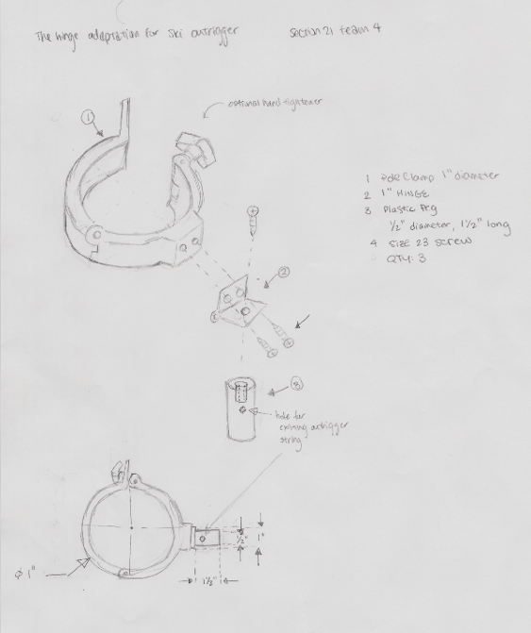

Sketch 2

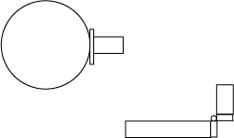
View from Top
View from Side

